Riphah International University
Gulberg Green Campus Islamabad
Faculty of Computing (WISH)



Name: Anisha Rehmat.
Sap ID: 78019.
Submitted To: Mam Nayab Khalid
Submitted by: Anisha Rehmat.

Supervision and Coordination

Miss Hira Jafar
Lecturer
Faculty of Computing

Lab Designers

Miss Nayab Khalid
Teaching Fellow
Faculty of Computing

Lab Task 6

Learning Outcomes:

• Explain the "has-a" relationship between two classes.
• Explain aggregation: a weak relationship where the part can live alone.
• Explain composition: a strong relationship where the whole owns the part.

Lab Tasks

Task 1:
A Team has many Players, but each Player can exist without the Team (he can join another team).
• Create a Player class with jerseyNo and name.
• Create a Team class with a list of Players.
• Deleting the Team must NOT delete the Players.
• In main, create some Players, add them to the Team, and display them.

Input:-

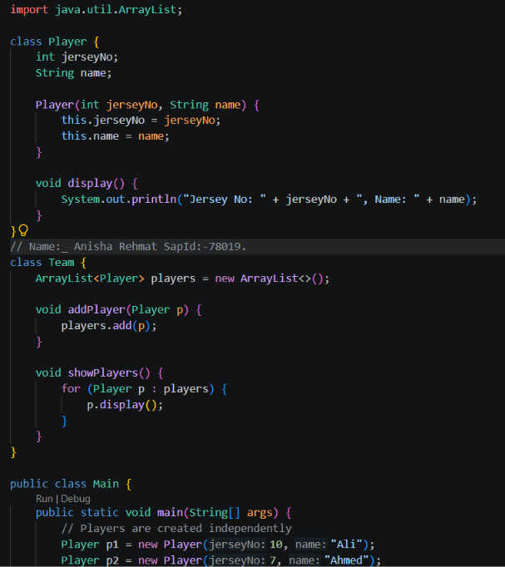
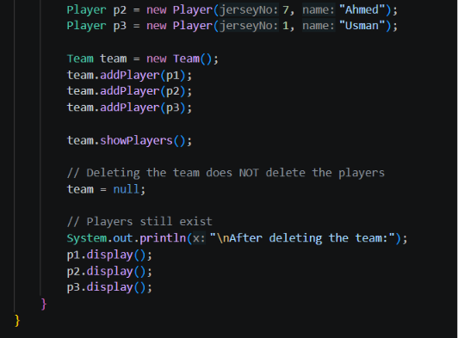

Output:-
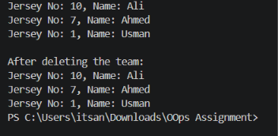

Task 2:
A Car has an Engine. The Engine is built inside the Car and cannot exist without it.
• Create an Engine class with a start() method that prints a message.
• Create a Car class that makes its own Engine inside the constructor.
• In main, create a Car and call drive(), which starts the Engine.

Input:-

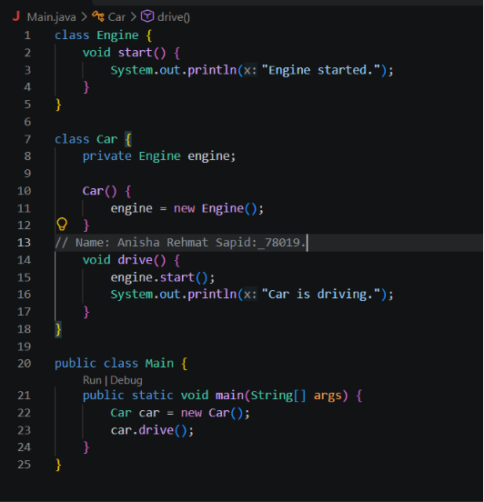

Output:-


